TROUBLESHOOTING THE EMERGENCY MODE ISSUES
After starting the Linux server, the system went into emergency mode like this:
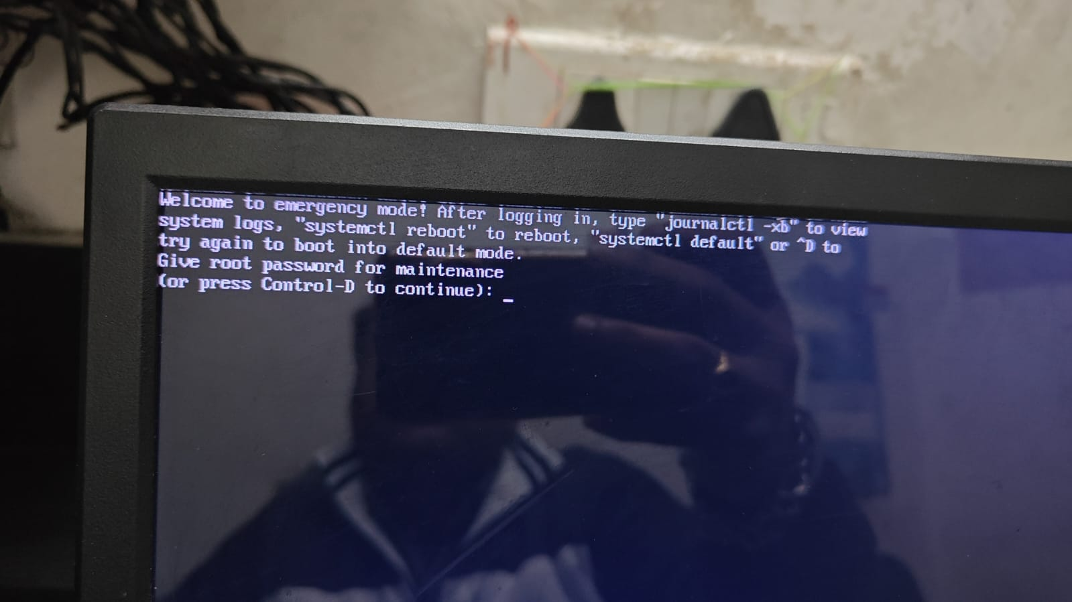
After logging, to find the what is reason for these issues follow the below-mentioned steps to find out.
STEP 1: After running the below-mentioned command, the output shows like this
- journalctl -xb
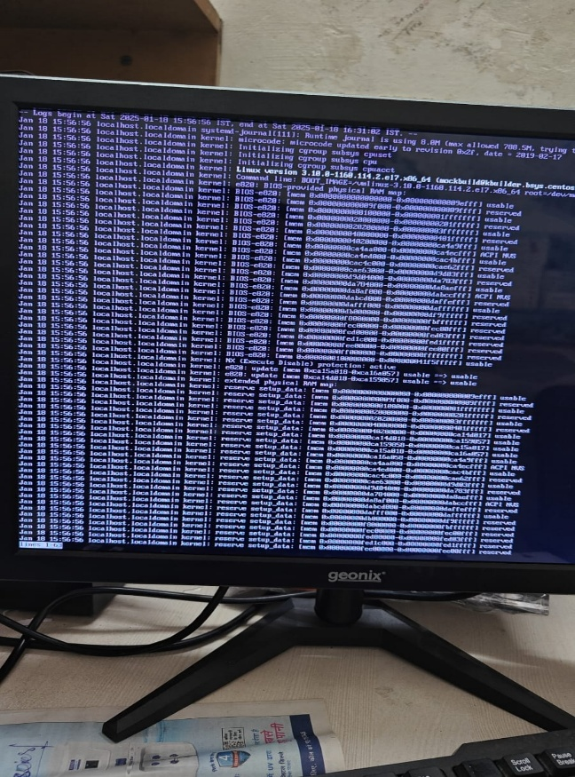
STEP 2: To find out the exact error run this command
- journalctl -b -p err
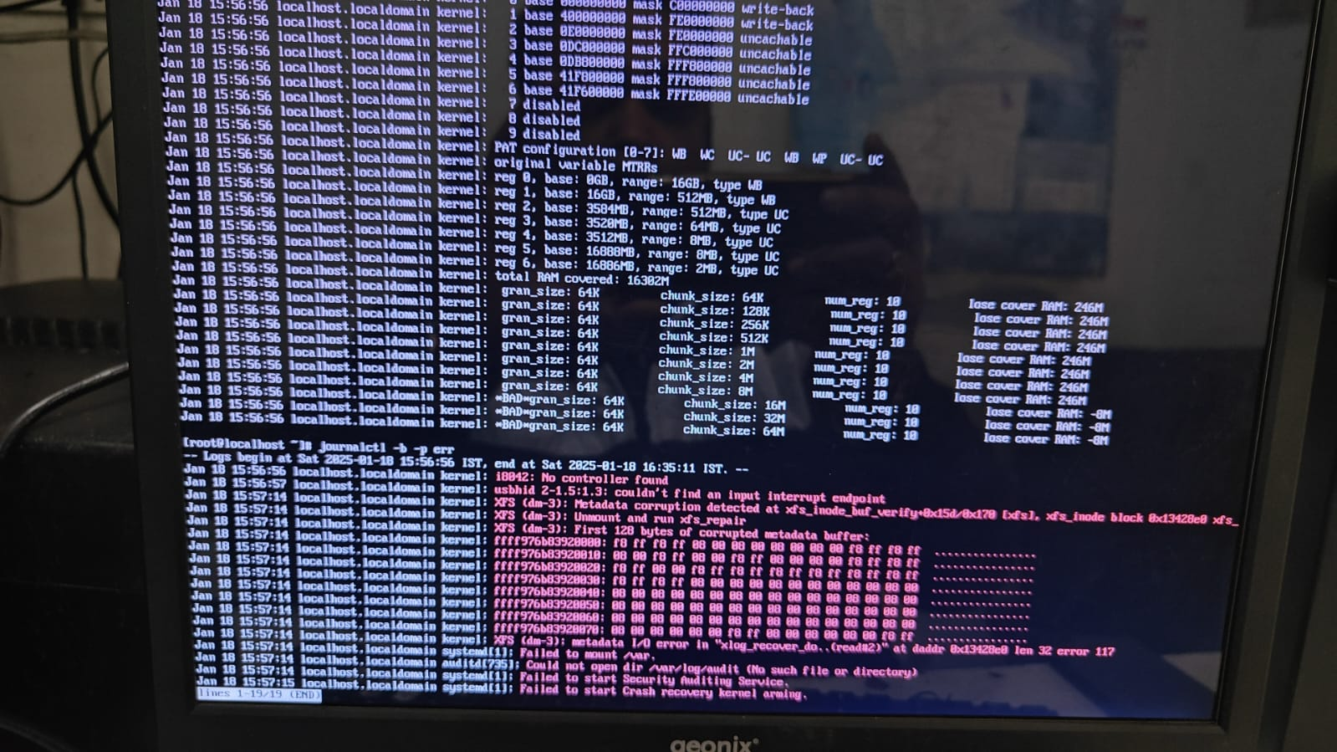
Several critical issues are showing in the logs like XFS filesystem errors and Service failures.
STEP 3: To find out system failed issues run this command will show only error-level messages from the current boot
- systemctl list-units --failed
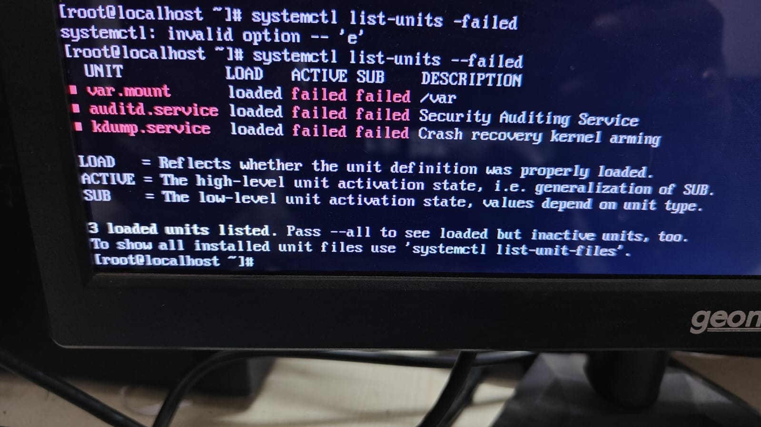
The /var directory isn’t mounted. So, that is the issue for the system going to emergency mode because that /var directory is mentioned in the fstab file.
STEP 4: Check fstab file entries
- cat /etc/fstab
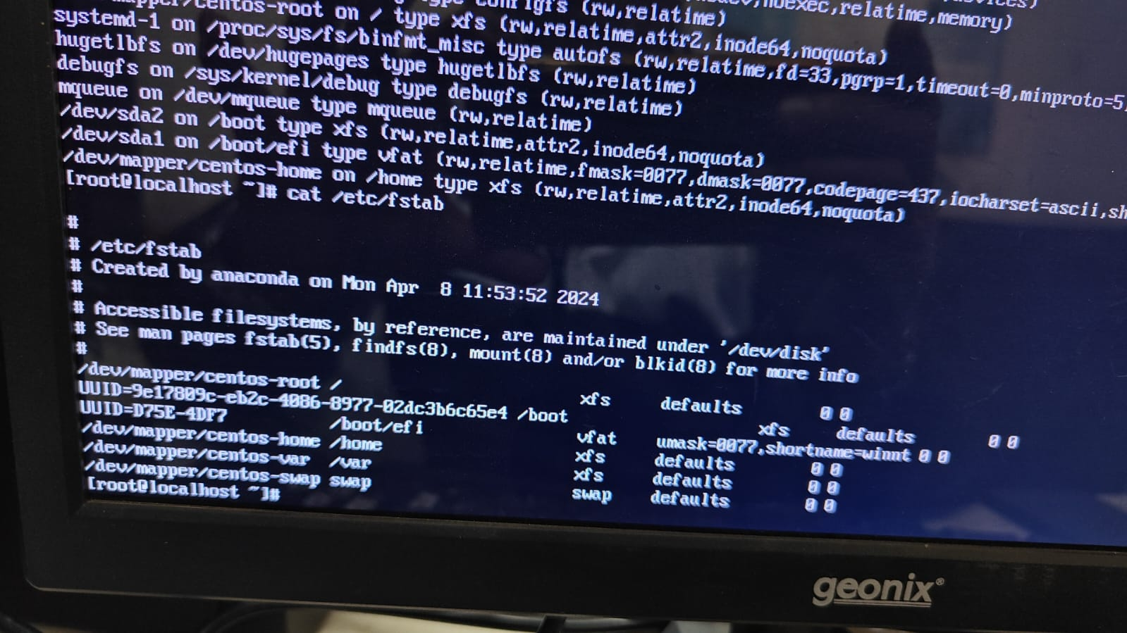
In fstab the /var directory is mentioned.
STEP 5: Check the disk space
- df -hT
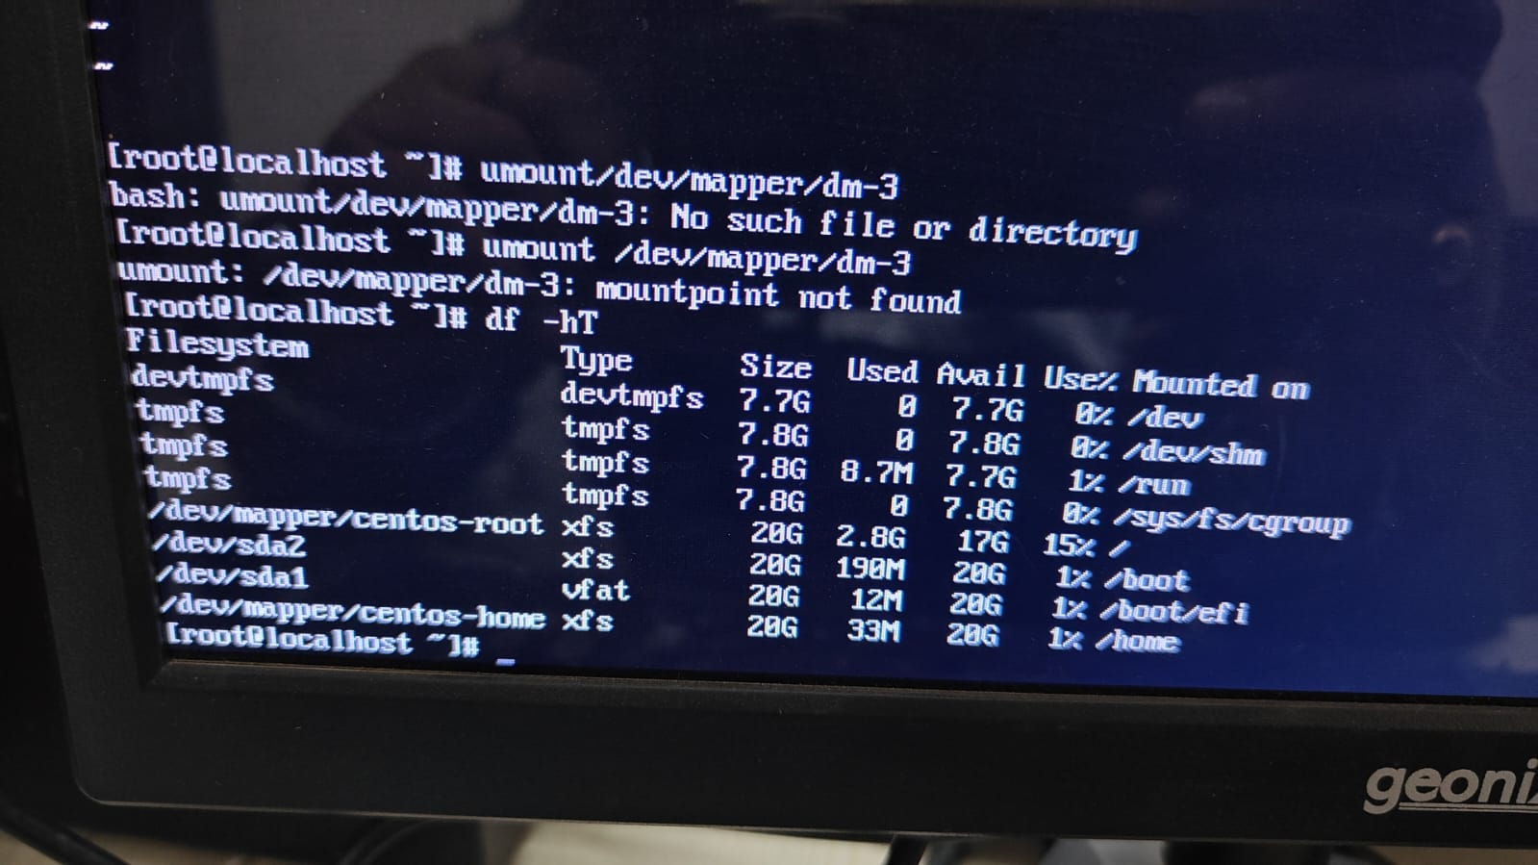
- lsblk
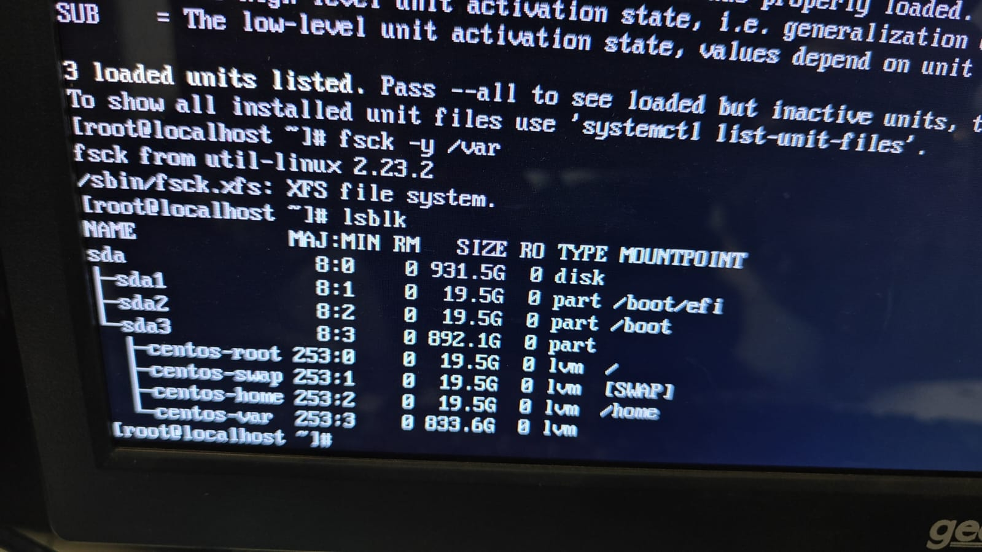
That /var directory isn’t mounted
STEP 6: Let’s try to mount that /var directory manually
- mount /var
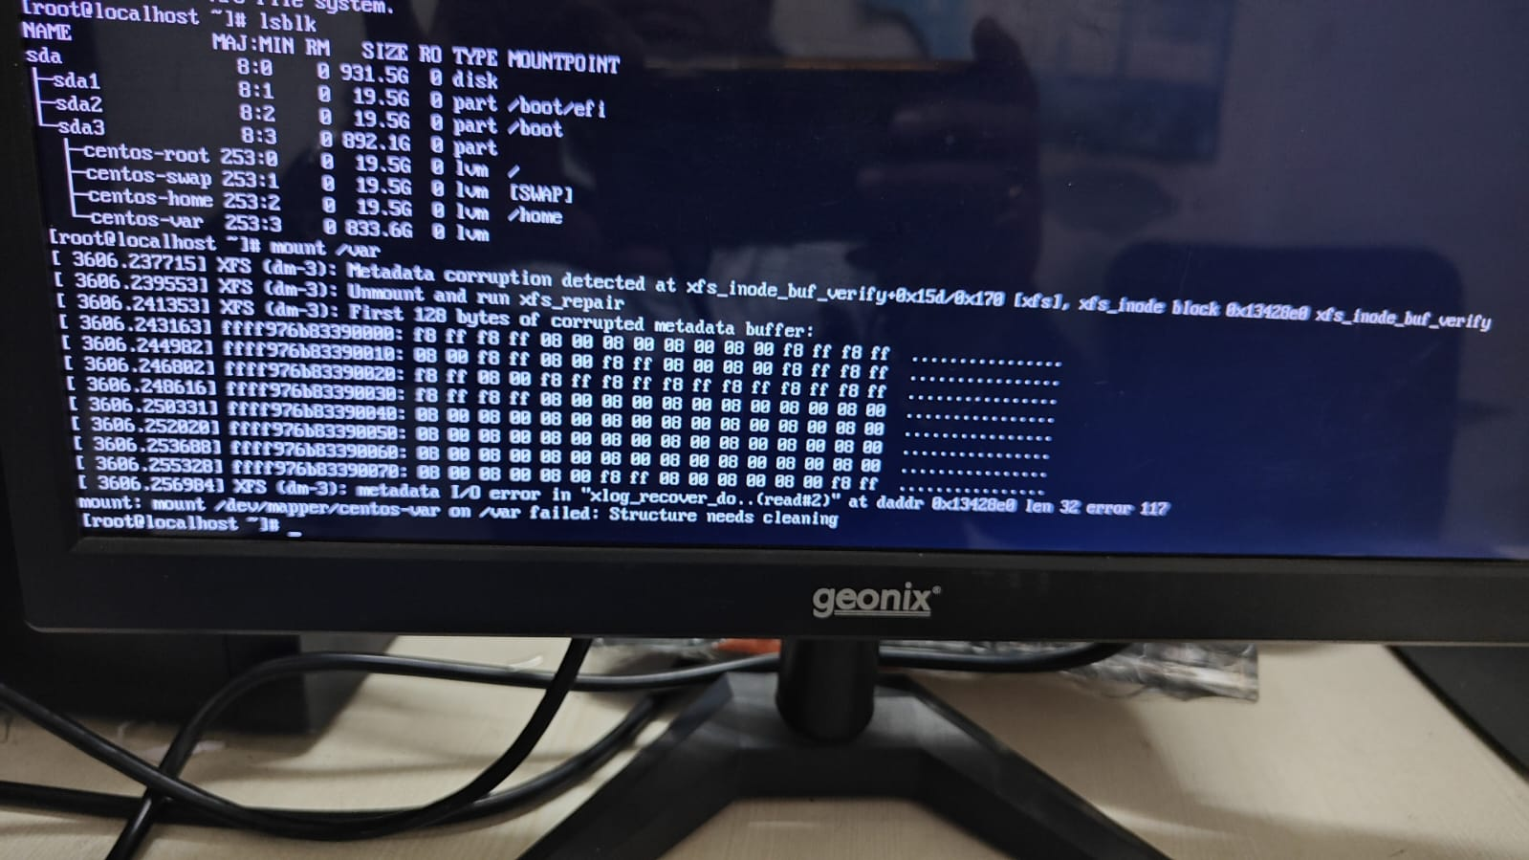
Manual mounting isn’t also not working means now that the filesystem has to be repaired.
STEP 7: Run xfs_repair with the force option to solve these issues because in this server they are using the xfs filesystem.
- xfs_repair -L -v /dev/mapper/centos-var
If that doesn't work, try with maximum verbosity and force options
- xfs_repair -L -v -V /dev/mapper/centos-var
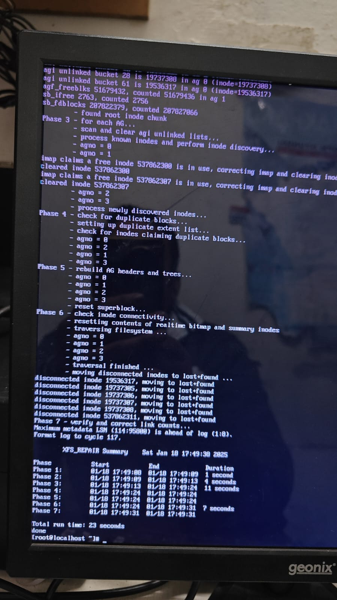
After running the 1st command xfs_repair -L -v /dev/mapper/centos-var the issues are solved.
STEP 8: After the repair is completed successfully, try to mount it
- mount /dev/mapper/centos-var /var
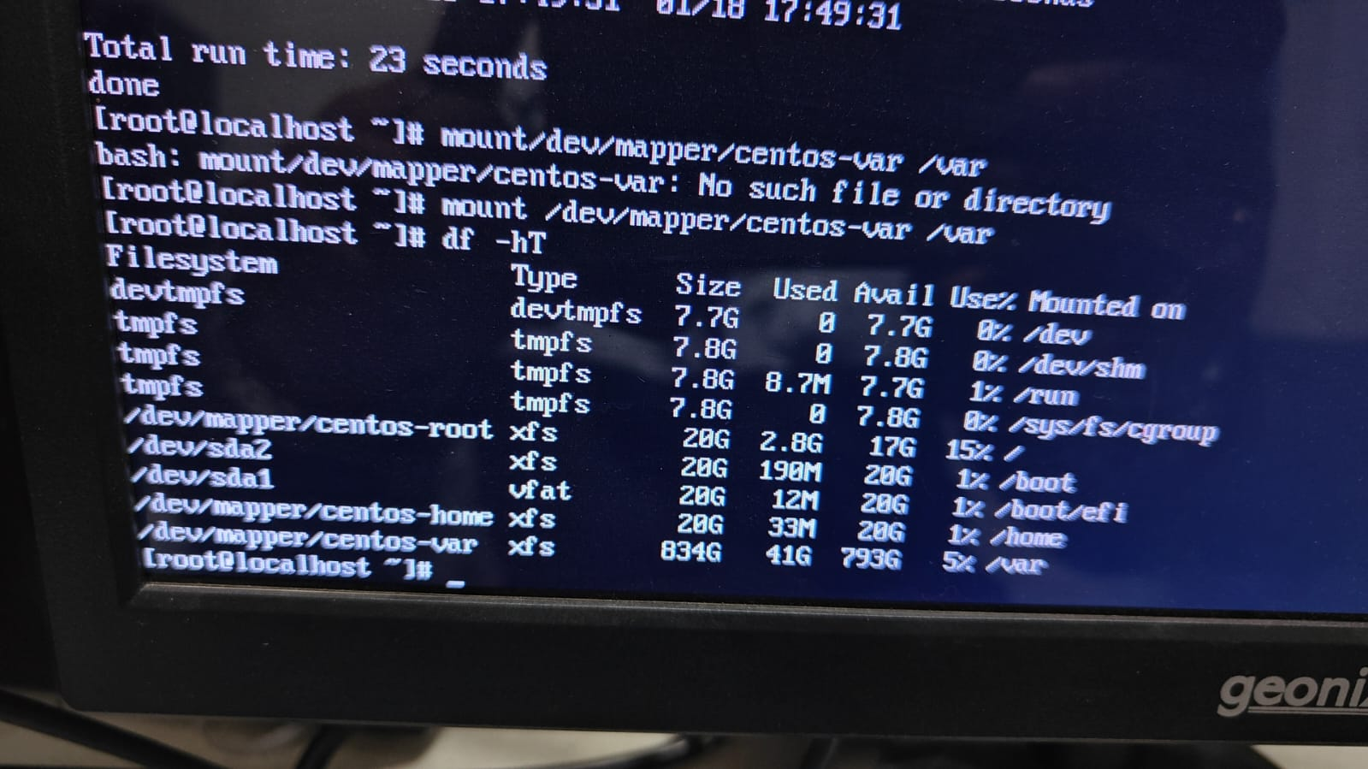
Now the manual mounting is working ensure it is mounted in the disk table.
- df -hT
- lsblk
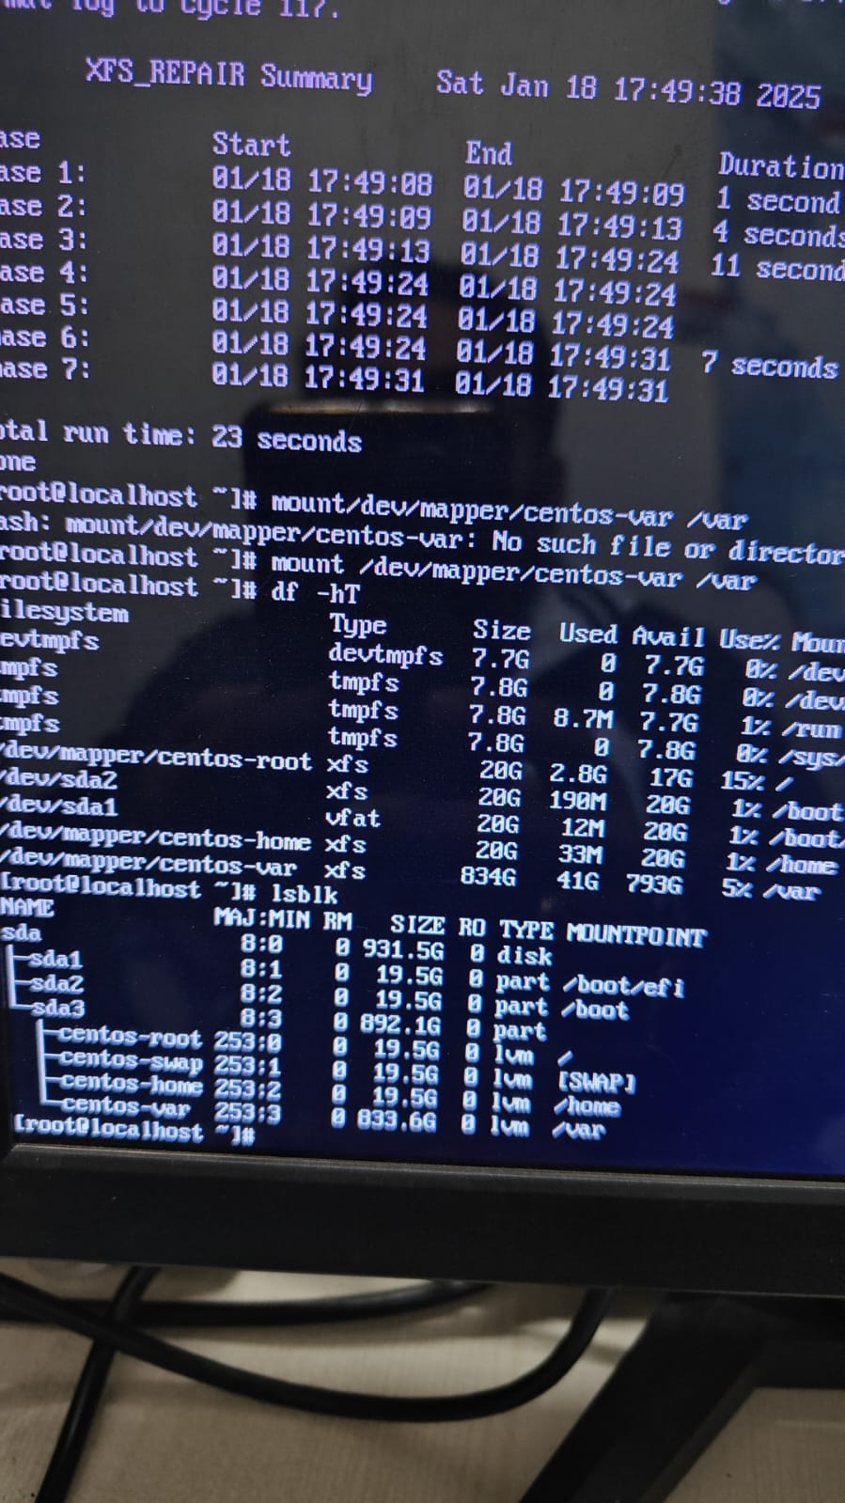
STEP 9: Reboot the system and ensure now the issue is solved or not.
- Reboot
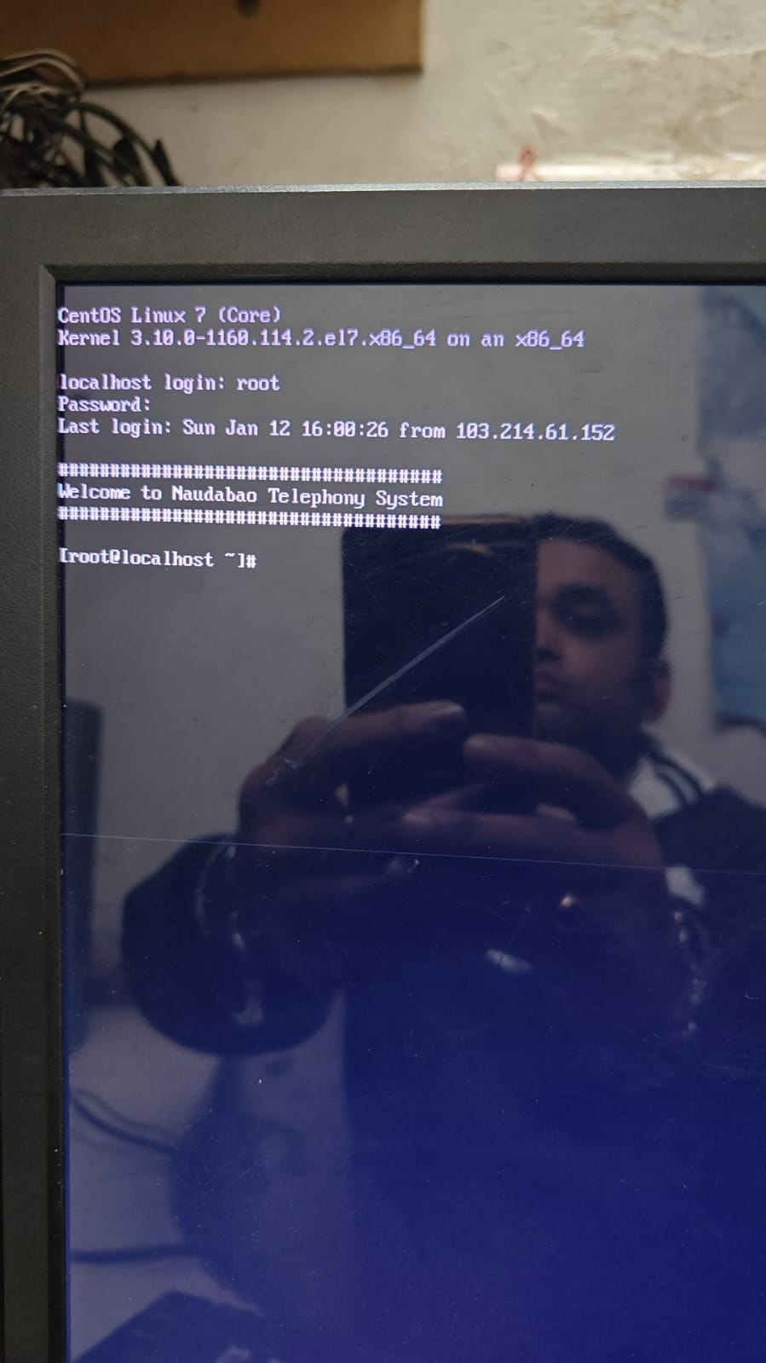
Now the issue is solved.

